The Small Research Telescope Challenge

National Academies Astro2010 Position Paper

Russell Genet, California Polytechnic State University and Cuesta College
David Rowe, Sierra Monolithics
Daniel Gray, Sidereal Technology
Susana Deustua, Space Telescope Science Institute
Andrew Aurigema, OTF Designs
Howard Banich, Rose City Astronomers
Mel Bartels, BB Astrosystems
Richard Berry, AstroPIX
Craig Breckenridge, Dynamic Structures Ltd.
Peter Chen, Lightweight Telescopes Inc., & NASA Goddard Space Flight Center
Gary Cole, Western Nevada College
David Davis, Toledo Scope Werks
Joe Haberman, PlaneWave Instruments
Rick Hedrick, PlaneWave Instruments
Arne Henden, American Association of Variable Star Observers
Jolyon Johnson, Cuesta College
Greg Jones, Eclipse Technologies
Tong Liu, Hubble Optics
Robert Nelson, Sylvester Robotic Observatory
John Ridgely, California Polytechnic State University
Greg Rohde, Superior Optical Supply
Kiran Shaw, Chroma Systems Pvt. Ltd.
Thomas Smith, Dark Ridge Observatory
Vera Wallen, Educational Consusltant
Xiao-Hua Yu, California Polytechnic State University

Summary

Large telescopes excel in the detailed study of faint objects at the edge of the observable universe and high-resolution examination of specific objects. However, small telescopes continue their valuable role in astronomical research through time series, networked, and other observations that only large numbers of small telescopes can provide—tasks which are cost prohibitive for large telescopes. Small telescopes also continue to play a vital role in recruiting and training the next generation of astronomers and instrumentalists, and serve as test beds for developments of novel instruments and experimental methods.

There is a synergy between large and small telescopes—an appropriate balance between the two. Yet the rising costs of large, cutting edge telescopes—absolutely necessary for the advance of astronomical science—has made it difficult for governmental and large institutions to also invest in small telescopes. Currently, a tight economy makes it difficult for smaller institutions to invest in small research telescopes themselves because the cost is a substantial outlay for them. Yet we need to maintain the balance between large and small telescopes to preserve their synergy.

A solution to this dilemma is to greatly reduce the cost of smaller telescopes. This would make them much more affordable for smaller institutions. We believe such cost reduction is possible through the transfer and innovative transformation of technologies from large to small telescopes, and by producing the resulting low cost small research telescopes in production quantity.
Technology transfer, innovation, and manufacturing in quantity form a natural evolutionary process, which is commonly seen in the application of new technologies. However, this process is often slow. It can be purposely accelerated in astronomy by developing bridging mechanisms between the large and small telescope communities, and by encouraging technology transfer initiatives, demonstration telescopes, and the production of affordable research telescopes.

The Alt-Az Initiative is an example of such purposeful acceleration. The Initiative is a self-funded, cooperative effort now well into its second year. The Initiative has utilized bridging mechanisms between the large and small telescope communities to launch over a dozen technical initiatives. Results from some of these efforts have already been incorporated in a demonstration telescope and the design of commercially produced telescopes.

The Initiative, from its inception, has involved undergraduate engineering students in its telescope and instrumental developmental efforts. The Initiative has also sponsored student research with small telescopes that result in published papers, and student researchers have presented their findings at Initiative workshops and conferences. Undergraduate students have also co-chaired the Initiative’s two conferences, and two students are coeditors of the Initiative’s forthcoming 40-chapter book.

Looking toward the future, we believe it would be appropriate to encourage this Initiative and other, similar efforts that accelerate the technology transfer process to produce lower cost, more capable small telescopes and instruments in a timely manner. A greater number of affordable small telescopes would not only support scientific research directly, but would increase undergraduate involvement in both research and development. Such encouragement could help maintain an appropriate balance between large and small telescopes and hence foster their continued synergy.

Small Research Telescopes
Their Enduring Value

In the age of giant telescopes, are small telescopes still useful? Weaver (2003) points out that

Both quantitative and qualitative arguments demonstrate the continuing importance of small telescopes to the astronomical endeavor. The quantitative arguments show that it is significantly less expensive per citation to use the smallest telescope that will accomplish the research. Both the quantitative and qualitative arguments show that the research accomplished by small telescopes is of continuing and lasting significance to the discipline as witnessed by their non-diminishing contribution to astronomy over the last century and the persistence of their citation histories.

Ringwald et al (2003) suggests that

Small telescopes can hold their own with larger instruments since more time is available on them. This makes possible monitoring campaigns, aerial surveys, and time-resolved campaigns, particularly if the telescopes are networked or automated—all difficult to carry out with larger telescopes, for which even small amounts of telescope time are in great demand.

The 2007 report of the Committee for Renewing Small Telescopes for Astronomical Research (ReSTAR) concluded that

The science to be done with small and mid-size telescopes remains compelling and competitive in the era of big telescopes. Small and mid-size telescopes continue to produce innovative science in themselves, and to provide precursor and follow up observations that enhance the scientific productivity of larger telescopes. Small and mid-size telescopes also enable scientific investigations that are not possible on larger telescopes.
The ReSTAR report went on to state that

Small and mid-size telescopes contribute additionally to the discipline through their training and educational functions and as test beds for innovative new instrumentation and techniques.

The Challenge
Increasing Participation through Greater Affordability

Weaver (2003) recalls that

Astronomy has a history of an essential synergy between small and large telescopes. This synergy can be maintained only if there is a reasonable number of well-maintained, well-instrumented smaller-sized telescopes.

Budget realities suggest, however, that both national and large-institution funding of expensive to build and operate but vital cutting edge large telescopes will make it difficult to also fund smaller telescopes in sufficient numbers to maintain an optimal balance between large and small telescopes. Further, during hard economic times, it will also be increasingly difficult for smaller institutions to fund small research telescopes themselves. So what is to be done? How can we maintain the balance and the synergy between large and small telescopes?

Meeting the Challenge
Lowering Costs through Advanced Technology and Quantity Production

In his book, Excursions in Astronomical Optics, Lawrence Mertz (1996), after noting that there is a “crying need for more observational facilities to outfit the throngs of young astronomers,” offered a solution:

The remedy, it seems to me, would be a proliferation of modest-sized telescopes in the 1.5- to -2-meter class that are sufficiently standardized for economy. The size is large enough to accomplish significant work, yet is small enough to become affordable if the design were standardized. All too frequently small institutions insist upon designing their own telescopes almost from scratch to fulfill their individual tastes. It should be evident that that course is hopelessly uneconomical, just as it would be uneconomical for each automobile to be custom designed. In essence, what is needed for observational astronomy is numerous … relatively inexpensive telescopes in the 1.5- to 2-meter class. Even at this modest size there does not remain much question between altitude-azimuth (alt-az) and equatorial mounting; computers now make the former more economical. Alt-az has the further advantage of simplifying the primary mirror support since tilting is restricted to the elevation axis.

We can expand on two of Mertz’s vital points. First, advances in technology, especially in computers and electronics—but also materials and other areas—can reduce telescope costs. Mertz illustrated this with an obvious example—shifting from equatorial to alt-az mounts. Second, true economy can only be achieved through quantity production. “One-off” telescopes will always be expensive. Although Mertz did not mention it, a third point could also have been made: large “one-off” telescopes with their sizeable development budgets often pioneer the new technologies which subsequently migrate to small production telescopes. These “tech transfers” are completed once clever ways are devised to drastically reduce costs so that the large telescope technologically-inspired breakthroughs can be incorporated economically into small telescopes in quantity production.

Two Telescope Tech Transfer Examples

Consider, as the first tech transfer example, alt-az telescopes themselves. The 5-meter Hale telescope, completed over a half century ago, remains the largest equatorial telescope ever built. There are now over 20 larger telescopes. Every single one is alt-az. Smaller telescopes are also heading down this same evolutionary pathway.

Until recently, most truly small (less than 1 meter) telescopes remained equatorial because alt-azimuth telescopes not only required constantly changing drive rates in both altitude and azimuth, but to avoid image smearing also required a field de-rotator—a significant complication. However, these complications did not apply to visual-only, manually operated, non-tracking alt-az telescopes. In their search for larger apertures at low cost, Amateur astronomers recognized the inherent advantages of an alt-az over an equatorial configuration. Today, low cost, easily transported, and now mass produced “Dobsonian” telescopes. Now one can purchase quantity manufactured Dobsonian telescopes from 4 to 32 inches in aperture that cost from $100 to $34,000. There are even a few larger and more expensive “Dobs” out there.

Mel Bartels (1994, 1999, and 2000) developed a very low cost control for alt-az telescopes that employed a personal computer, a small electronics board, and three stepper motors for, respectively, altitude, azimuth, and instrument rotation. Soon Mel’s Compan, BB Astrosystems was selling the alt-az control system electronics for a very low cost. The user supplied the stepper motors and a personal computer and computerized their Dobsonian telescopes. More recently, Dan Gray’s Sidereal Technology has offered the electronics and software for a complete alt-az, DC servo control system, including instrument rotation and focus for about $1000. Dan graciously suggested he was inspired by Microcomputer Control of Telescopes (Trueblood and Genet 1985).

For the second example of tech transfer from large to small alt-az telescopes, consider telescope weight, stiffness, and materials. As computers became more powerful, finite element analysis (FEA) resulted in increasingly lightweight yet stiffer large telescopes—leading eventually to today’s highly optimized truss structures. Lighter weights lowered costs, while stiffer structures allowed control systems to more effectively counter wind gusts. Stiff and economical steel remained the material of choice for large alt-az telescopes.

Dobsonian telescopes also evolved to become much lighter, stiffer, and more truss like. They shifted from ordinary plywood and cardboard Sonatubes to hardwood veneer plywood and aluminum trusses. A recent small alt-az telescope, the 18-inch Cal Poly telescope (discussed further below), was designed by undergraduate engineering students using FEA, and features a carbon fiber composite structure. Carbon fiber composites have about three times the stiffness to weight ratio of steel. Although carbon fiber is too expensive a material to use in large telescopes, they can be an advantage in smaller telescopes.

A good example of a modern, lightweight, alt-az telescope is Howard Banich’s (2004) 28-inch, computer-controlled, all aluminum alt-az telescope which weighs about 330 lbs. Howard transports his telescope in the back of a VW Eurovan, and can assemble or disassemble it in less than ten minutes. Watch Howard in action in a time-lapse video at http://hbanich.googlepages.com/28inchteardownvideo. A somewhat similar telescope, SpicaEyes, is available commercially in apertures up to 32 inches.

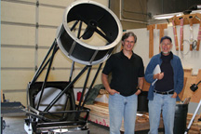 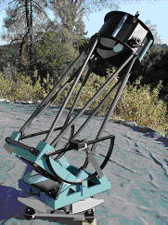 (Left) Howard Banich’s portable 28 inch telescope at the first Alt-Az Initiative Workshop in Portland, June 2007. Howard is on the left, and Russ Genet is on the right. (Right) One of SpicaEyes commercially produced all-aluminum, computer-controlled alt-az telescopes.

It might be noted in passing that not all tech transfers have been from large to small telescopes. Full telescope and observatory automation, remote Internet access, and global networking have all been pioneered by small telescopes. Larger telescopes subsequently adopted aspects of these technologies. These are all clear cases of reverse tech transfer.

Two Separate Telescope Development Communities

Although large to small alt-az telescope tech transfer is taking place, the fact is that the large and small developmental communities are, in the main, quite separate, with limited between-community communications. Large alt-az telescope developments are generally undertaken by a combination of paid professional engineers and astronomers. These telescopes are built in high-bay machine shops equipped with large cranes. The cost of such telescopes now often exceeds $50 million, and the telescopes can weigh over 1 million pounds. Each telescope development is, typically, unique. Information is exchanged through the meetings and journals of engineering organizations such as the Society of Photo-optical Instrumentation Engineers (SPIE), and through professional astronomical meetings such as those organized by the American Astronomical Society (AAS). A classic large telescope design book is The Design and Construction of Large Optical Telescopes (Beley 2003).

The development of small, Dobsonian alt-az telescopes, on the other hand, has mainly been undertaken by unpaid amateur telescope makers (ATMs) as an avocation. It might be noted, however, that many ATMs are, by vocation, scientists, engineers, or technicians. These telescopes are being built at home or small manufacturing shops, often with simple tools. Costs are typically a few thousand dollars, and telescopes weigh a few hundred pounds. Although many ATM-built telescopes are unique, several small telescope manufacturers produce identical telescopes in quantity. Information is not only exchanged on-line through a variety of email lists and web sites, but also through annual regional conferences such as the Riverside Telescope Makers Conference (RTMC). The quarterly journal, Amateur Telescope Making, which was the primary published record for Dobsonian developments for many years, has now been superseded by Amateur Astronomer. Sky & Telescope and Astronomy Technology Today also feature small telescope developmental articles. A classic small telescope book is The Dobsonian Telescope (Kriege and Berry 2003).

Instrumentation

The past decade has seen great advances in the availability of research grade instrumentation suitable for smaller telescopes. These advances have been driven by a combination of evolving technology and by the emergence of a community of advanced amateur astronomers with modest budgets but very high standards.

This combination has allowed instrument makers such as SBIG, Optec, Shelyak, and others to bring to market products with capabilities that were previously available only to well financed institutions. Equally important has been the emergence of a software infrastructure (ASCOM) that unifies instrument automation and telescope control.

To give just a few examples of progress over the last decade: High quantum efficiency, science grade imaging cameras have gone from 1.5 mega pixels (MP) to 16 MP. Small telescope spectrographs, a category that hardly existed a decade ago, now include R~17K Littrow and fiber fed Echelle instruments. The cost of polarimetric instruments has declined by a factor of 10 thanks to achromatic polymer waveplates from Bolder Vision Optik. And whole new instruments are now available such as the SSP-4 that provide JH band infrared photometry. Small telescope IR spectrographs and imagers are within sight.

These individual instruments are generally lightweight, well documented, essentially maintenance free, and have multivendor software support. Moreover, they were designed to match telescopes in the .3m to 1.5 meter range because that is where their customers are.

Dedicated Telescopes, Automation, and Operation and Maintenance Costs

General purpose telescopes, which have to meet a wide range of requirements, tend to be more expensive than dedicated telescopes to purchase, and certainly are more expensive to operate and maintain. The initial cost of a general purpose telescope at a major observatory, while it can be considerable, is typically much smaller than the long run operation and maintenance (O&M) costs over the telescope’s life time. The cost of paying O&M staff for decades adds up. Furthermore, the cost of the instruments, substantial to begin with and expensive to upgrade over the years, can be a large fraction of the life cycle cost. The long-term burden of O&M costs at the national observatories became so high that a number of smaller scopes had to be closed because there was insufficient money both to operate them and also build and operate new, larger, cutting-edge research telescopes.

Taking instruments on and off a telescope on a regular basis is costly in both manpower and equipment wear and tear. Dedicated telescope/instrument combinations, on the other hand, can be designed together for a specific mission area with the instruments permanently emplaced on the telescope. A computer-controlled selector moves the optical beam between the instruments in a cluster. Dedicated telescopes may be the way of the future, because they are cheaper to operate and maintain, particularly when they are operated in a service/robotic mode.

If a dedicated telescope with a permanent, computer selectable cluster of instruments is run robotically, care has been taken to obtain high reliability components, and maintainability issues have been carefully addressed, then O&M costs can be quite low. The National Science Foundation has traditionally funded the telescopes at colleges and universities, but not, of course, for individuals. However, if small, dedicated, robotic research telescopes could be made inexpensively enough, they might become affordable enough for individuals and small informal groups entirely on their own to purchase, operate, and maintain.
The Alt-Az Initiative
An Experiment in Purposeful Evolutionary Acceleration

Meeting the challenge of increasing the number of small research telescopes by lowering their costs through technology transfers and quantity production is taking place across a broad front, albeit at a rather slow pace. This natural technical evolutionary process (Basalla 1988) could be accelerated, however, through purposeful tech transfer “bridging mechanisms” between the large and small alt-az telescope development communities. These mechanisms include enhanced inter-community communications, as well as the encouragement of tech transfer initiatives, tech demo telescopes, and quantity production of unusually low cost, small research telescopes. We consider, below, a pilot project “experiment” in the purposeful evolutionary acceleration of small research telescopes.

Initiative Overview

The Alt-Az Initiative was established in June 2007. The Initiative has been self-funded, with individuals and small firms donating time and materials. The Initiative focused, from its inception, on the development of “advanced technology,” lightweight, low cost, 0.5 to 2.0 meter alt-az research telescopes. To provide even more focus, a specific goal, a “challenge” was established early on, to develop a lightweight, transportable, 1.5 meter alt-az research telescope. From its inception, the Initiative also concerned itself with instruments, dedicated scientific research programs, and automation (as well as remote access and networking).

Special emphasis has been given by the Initiative to those instruments and research programs which would most benefit from low cost 1-2 meter telescopes/instrument combinations. These include faint object time series optical and near IR photometry, time series fiber-fed low and medium resolution spectroscopy, and high speed photometry.

Special emphasis has also been given to the involvement of undergraduate students, who have participated since the Initiative’s inception in research, development, conferences, and publications.

Considered separately below is each of the five key elements of the Initiative:

Enhanced communications
Tech transfer initiatives
Tech demo telescopes
Transfers to quantity production
Student participation in research and development

Enhanced Communications

Although the bulk of the Initiative’s communication is via email and telephone, Initiative members have gathered together in person at eleven workshops to date. The two founding workshops were held in June 2007 in Portland (Sidereal Technology) and San Luis Obispo (California Polytechnic State University). A large workshop followed in October in Dallas, and there have been a number of workshops since then, including workshops in Hilo with Gemini and Subaru engineers. The next workshop is June 6-7, 2009, in conjunction with the American Astronomical Society’s summer meeting in Pasadena, California.

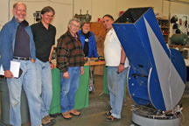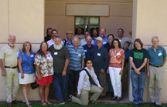
Founding Initiative workshops, June 2007: Sidereal Technology in Portland (left) and California Polytechnic State University in San Luis Obispo (right).

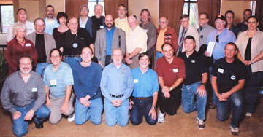
Initiative workshop in Dallas, October 2007

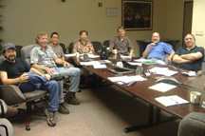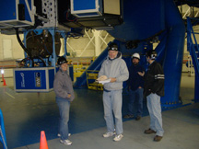
Initiative Workshop, Hilo, January 2008, at Gemini Headquarters and on tour of the Gemini Telescope

The Alt-Az Initiative has also sponsored two major conferences, one held in San Luis Obispo in June 2008 and the other in Hawaii in January 2009. These four and five day conferences, respectively, were well attended, and each conference included several workshops and some three dozen talks, many of which will appear as chapters in the Initiative’s forthcoming book. The Initiative’s next conference will be in Hawaii, February 8-12, 2010.

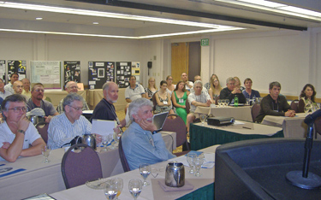

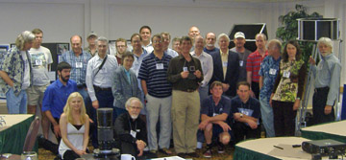
Initiative Small Telescope and Astronomical Research (STAR) Conference at
San Luis Obispo, June 2008 (Both pictures above)

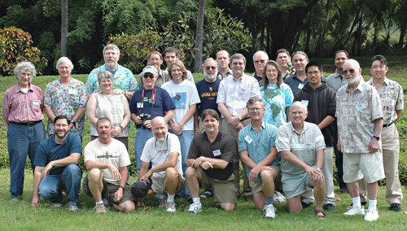
Initiative Galileo’s Legacy Conference at the Makaha Resort, Hawaii, January 2009

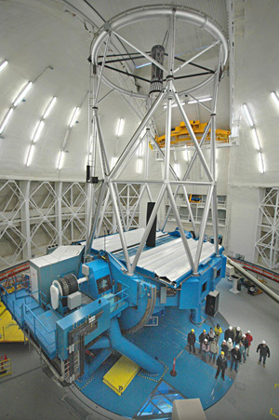
Galileo’s Legacy was followed by an insider’s
tour of the 8-meter Gemini Telescope on
Mauna Kea on the Big Island of Hawaii,
January 2009.

Not only are the Initiative’s workshops and conferences open to all, but developments are being shared with the larger astronomical community through published papers, articles, and a low cost, forty chapter book, The Alt-Az Initiative: Lightweight Telescope Developments and Scientific Research Programs. This book is in final editing, and will be available from the publisher this summer (2009). This book is divided into eight sections:

Light Weight Optics
Telescopes
Astronomical Instruments
Observatories and Enclosures
Automation, Networking, and Remote Access
Small Telescope Research
Research as Undergraduate Education
Examples of Undergraduate and High School Research

Details on the Initiative’s workshops, conferences, and publications, as well as useful references, links, etc. are available on the Initiative’s web site, www.AltAzInitiative.org.

Tech Transfer Initiatives

So far, a dozen technical initiatives have been completed or are underway. We will consider by way of illustration, example initiatives drawn from three areas:

Telescope drives and controls
Lightweight primary mirrors
Active primary mirror control

Telescope Drives and Controls During the early stages of the Initiative, several members visited Magdalena Ridge Observatory, and were given a very thorough tour and explanation of the modern, 2.4-meter alt-az telescope by its Chief Engineer, Elwood Downey, and its Lead Engineer from EOS Technologies, Kevin Harris. The 2.4 meter MRO telescope employs direct drives. The telescope itself acts as the bearings and “frames” for the azimuth and altitude motors. A ring of permanent magnets in both altitude and azimuth are the motors’ rotors, and similar rings of coils that act as the stators. Magnetic forces between the rotor and stator move the telescope based on the output of high resolution, on-axis encoders, with the motion determined by a servo algorithm. There are no gears, friction rollers, belts, or any other mechanical reduction devices to introduce periodic errors or compliance that could reduce the telescope’s stiffness and natural frequency. As noted in Bely’s (2003) classic book, The Design and Construction of Large Optical Telescopes, “A direct drive, which eliminates all mechanical systems, is the ultimate choice.”

While the stators, rotors, and rather computer-controlled electronics are all commercially available, they can be more expensive than many some modest-aperture telescopes. Initiative member Dave Rowe devised a very low cost, axial flux, direct drive motor for telescopes. Normal direct drive motors are radial flux motors. The radial “one ring inside another” configuration is energy efficient, but involves an expensive arrangement of magnets, coils, and soft steel to contain the flux. Rowe realized that energy efficiency was not important for modest aperture alt-az telescopes, and devised an axial flux motor, with a simple coil ring placed on top of a permanent magnet ring. The axial flux direct drive motor only cost about $300 per motor in magnets, wire, and steel, and is extremely easy to build.

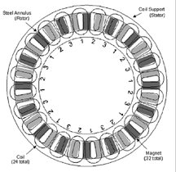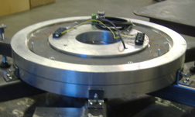
The axial-flux direct drive motor devised by Initiative member Dave Rowe. An 18-inch diameter motor was readily assembled from parts and materials that cost only $300. The azimuth assembly on the right includes the motor, bearings, and high resolution tape encoder and read head.
Direct-drive, direct-position-reading servo systems are much more difficult to control than ordinary brushed DC motors, and require not only high resolution on-axis encoders as inputs, but high-speed, computation of the control system filters a feedback algorithm. Initiative member Dan Gray at Sidereal Technology designed a low cost control system that handles two “brushless,” AC synchronous, direct drive telescope motors. Gray also wrote all of the real-time, embedded firmware for the controller, and the PC-based command-and-control software.

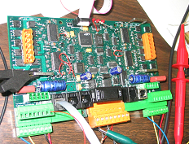

The low cost direct drive servo motor controller devised by Initiative member Dan Gray. An on-board microcomputer performs the requisite trigonometric and other calculations at high speed to control the current through the motor’s coils.

Lightweight Primary Mirrors Both large mountaintop alt-az telescopes and their diminutive lowland brethren share a common obsession with lightweight primary mirrors. Without lightweight mirrors, telescope weights and hence costs rapidly get out of hand. For small telescopes, especially in the 1-2 meter aperture range, transportability and assembly are vital issues if 18-wheelers and cranes are to be avoided. Initiative members have been addressing the challenges of lightweight yet low cost primary mirrors for small alt-az research telescopes from several perspectives.

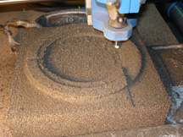
Initiative member Andrew Aurigema machined the top surface of Foamglas® material from Pittsburgh Corning. David Davis then fused thin glass plates to the Foamglas to form a lightweight mirror blank.

Several Initiative members have been investigating the use of foam glass as lightweight spacer/structural material between the top and bottom glass plates of a primary mirror. Pittsburgh Corning makes Foamglas, a rigid insulating material used in LNG ships, many industrial applications, and even under heated concrete runways in cold climates such as Alaska. Andrew Auregema has been machining concave surfaces in the tops of Foamglas blocks, while David Davis has been slumping and fusing glass plates to Foamglas in his kilns. Attendees at the recent Galileo’s Legacy conference in Hawaii were intrigued when David pointed out that Foamglas sandwich mirrors float on water. He then proceeded to toss a Foamglas mirror blank on the floor without damage. Soda lime Foamglas comes in a number of densities, and there is also a low coefficient of temperature expansion borosilicate version of Foamglas.

Initiative members are investigating the use of low shrinkage adhesives to fasten pre-slumped top plates (and flat bottom plates) to Foamglas cores as an alternative to kiln fusion. A group in Italy under the direction of Giovanni Pareschi is also working on Foamglas mirrors, and the Director of Development at Pittsburgh Corning, Steve Badger, has been generously supportive of these Foamglas mirror developments.

Initiative member Peter Chen has been developing very lightweight carbon fiber replica mirrors for several years and is now achieving success with this approach. Initiative member Kiran Shah is experimenting with polyurethane replica mirrors. Shah’s mirrors have a solid polyurethane front surface supported by a dense polyurethane foam body that is formed in a mold.

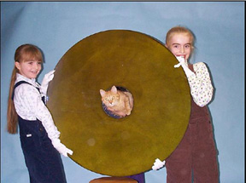
An ultra-lightweight, experimental carbon fiber composite mirror designed and fabricated by Initiative member Peter Chen. A two meter telescope composed of a number of such mirrors in a multiple-mirror configuration could provide the ultimate lightweight alt-az telescope.

David Davis has been experimenting with slumped meniscus mirrors. He builds his own kilns and does his own grinding, polishing, and figuring by machine. Work is also continuing on the development of sandwich mirrors with glass spacers by Tong Liu at Hubble Optics.

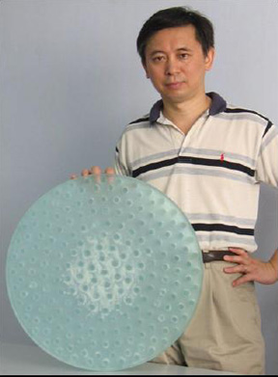
Initiative member Tong Liu and the lightweight sandwich mirror he developed for the Cal Poly 18 tech demo telescope. Glass spacers are fused between two thin glass plates.

Active Optical Correction Initiative members Mel Bartels and David Davis are both interested in seeing how far thin, slumped meniscus mirrors can be “pushed” with respect to both aperture and thinness. Soda lime or borosilicate float glass can only be procured in thicknesses up to 25 mm. As apertures of meniscus mirrors this thin increase, however, an aperture will eventually be reached where, similar to the situation with mountaintop alt-az telescopes, corrective forces under computer control will need to be applied to the primary mirror if it is to retain its proper figure as the telescope changes its altitude and hence the gravity vector acting on the mirror.

In a visit to the Gemini North eight meter telescope, Initiative members discussed the Gemini’s “voice coil” active mirror support system with Chris Carter, then Gemini’s control system engineer (Chris recently joined the Thirty Meter Telescope developmental team). Chris suggested that for smaller telescopes, a voice coil support system to “tweak” the mirror into proper shape as altitude changed could be made at low cost. Two undergraduate electrical engineering students at California Polytechnic State University are now developing low cost electronic controls for voice coil meniscus mirror adjustment. They are also, in a parallel effort, developing the electronics for small stepper motor mirror tweaking.

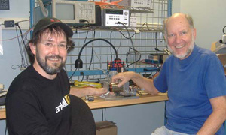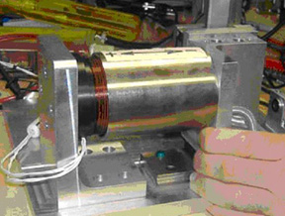
Chris Carter and Russell Genet examine one of the Gemini’s spare voice coil actuators used to maintain the shape of Gemini’s actively corrected primary mirror. Chris suggested that active mirror support would be a good tech transfer candidate.

In both cases, our only concern is to make very low frequency (less than once per second) adjustment of the primary mirror to correct for the lowest order Zernike terms, especially astigmatism, as a function of altitude. The requisite adjustments can, we believe, be calibrated “off line” on a number of bright stars distributed in altitude with a coefficient-determination algorithm that minimizes the spread of the stellar image. During operation, the current altitude of the telescope will be noted, and the required settings interpolated from a lookup table. This approach is used by the eight meter Subaru telescope with recalibration of their look up table only required about once a year.

Finally, there is a third approach we are considering for active optical correction, and this is the use of a semi-passive bimorph mirror. These mirrors consist of two thin disks, one of active piezo material coated with a thin layer of conductive metal on each side, and the other a thin front surface mirror. The two disks are bonded together with a low shrinkage adhesive. The back metal coating on the piezo disk can be divided into sections. When a high voltage (100 to 350 volts) are applied to the sections, the piezo materials in each section contracts or expands some amount, depending on the applied voltage and its polarity. The combination of these expansions and contractions can warp the thin mirror disc in a modal manner. A computer controls these voltages through a digital-to-analog converters and high voltage operational amplifiers.

Instead of using actuators to apply forces directly to the primary mirror itself, a much smaller, semi-passive bimorph mirror near the instrumental payload is distorted via applied voltages in such a manner as to cancel out the gravity-induced distortions in a lightweight primary mirror. These corrections can be applied in a manner similar to what was discussed above, i.e. via a lookup table versus altitude.

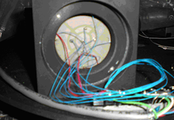
Initiative member Greg Jones’ low cost, semi-passive bimorph mirror.

Instrument Clusters One of the Alt-Az Initiative’s members, Gary Cole, has been focused on the concept of developing lightweight automated science instrument clusters to maximize the number of available observing modes on a single telescope. This in turn multiplies both the research and educational value of the facility.

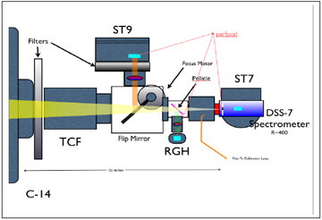
Instrument cluster developed by Gary Cole. Permanently mounted, yet remotely
switchable instruments increase system versatility and, compared to mounting and
demounting instruments, greatly reduce the costs of operation and maintenance.

The core of this project has been the development of a programmable, lightweight, 4 way instrument selector that can tie together, both optically and mechanically, a complete suite of science instruments including the new 50mm CCD cameras. This device is just now entering production from Optec, Inc.

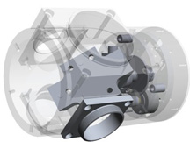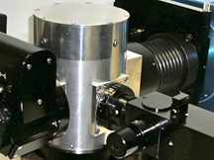
Left, 3-D drawing of the lightweight programmable instrument selector that will be offered by Optec, Inc. Right, bench testing of the lightweight instrument cluster prototype.

As an example, the prototype 20 pound cluster provides: target acquisition, imaging, Sloan band photometry, deep R~400 survey spectroscopy, R~10000 spectroscopy, JH band infrared photometry, and broadband dual beam imaging polarimetry. The selector and instruments operate as IP network devices. The data is gathered in FITS formats. A single laptop operates the entire cluster along with the telescope under the control of an automated observation scheduler.

Assuming a typical 1000 hr/year observing program and five year lifetime, the amortized cost of this instrument cluster is less than 5$/hour. The range of both research and education opportunities provided by an instrument cluster such as this one on a 1 meter platform is very exciting.

Optec SSP-4 NIR JH Band Photodiode Photometer Automation Currently, near infrared imaging cameras remain quite expensive ($50K and up) because these cameras cannot be fully implemented in silicone chips alone, requiring a hybrid combination of materials. While efforts are underway to reduce the cost of these cameras, a much lower cost, and easier to handle option for JH band near IR photometry is available in Optec’s SSP-4 photometer for only $3K. The SSP-4, developed by Optec, in cooperation with the American Association of Variable Star Observers, is ideally suited for observing long-period Mira and other variable stars.

Initiative member Dan Gray has automated the filter changing and flip-mirror functions of the Optec SSP-4 to allow fully automatic operation. Dan and Initiative member Russ Genet made a test run on this modified SSP-4 at the University of Oregon’s Pine Mountain Observatory in July 2008. Dave Rowe analyzed the resultant data.

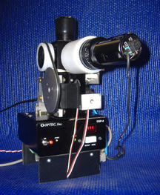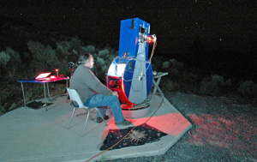
The Optec SSP-4 near IR photometer, left, modified for automated operation, was evaluated on Dan Gray’s automated 14-inch alt-az telescope (right) in a test run at Pine Mountain Observatory.

Tech Demo Telescopes

The objective of the Initiative’s first tech demo telescopes was to combine together various elements from individual technical initiatives and to gain experience as a group in building and operating a complete system.A 1.5 meter, dedication-mission demonstration telescope is under consideration.

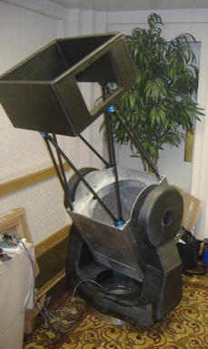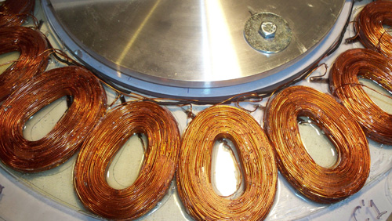
The Cal Poly 18 alt-az telescope designed and built by Initiative members, including undergraduate students at California Polytechnic State University. Final fabrication and assembly was completed at Sidereal Technology in Portland. On the right are the coils for the altitude direct-drive motor.

The modest aperture (18 inch) Cal Poly 18 (CP 18) alt-az telescope was designed and built not only as a technical demonstration, but also for eventual use by student researches at California Polytechnic State University. The telescope’s drive system has no gears, belts, or friction wheels; instead, as described earlier, direct drive motors and high resolution encoders are completely integrated into the bearing assemblies and telescope’s structure. In altitude, for instance, a ring of permanent magnets is firmly mounted to the OTA while an opposing ring of coils is mounted on the inside of a fork arm. The electronic control system has been designed to operate these brushless motors in a high precision mode.

To achieve the highest possible closed loop servo bandwidth, the structure was designed—by Cal Poly students using finite element analysis as well as traditional analytic tools—to have an unusually high natural frequency. The direct drive system and stiff structure effectively counters wind gusts when such a telescope is operated out in the open or within a roll-off roof observatory.

Transfers to Quantity Production

PlaneWave Instruments CDK 700 Telescope Construction has begun at PlaneWave Instruments by Initiative members Rick Hedrick and Joe Haberman and their associates on a production, 0.7 meter, corrected Dall Kirkham telescope with Nasmyth foci. The telescope employs direct drive motors and control system electronics and software that are similar to and based on the Initiative’s experience gained with the Cal Poly 18 demo telescope described above.

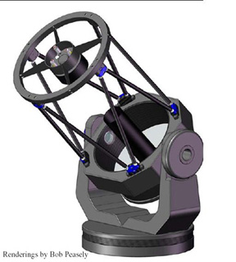
The PlaneWave Instruments CDK 700 telescope. The Nasmyth configuration facilitates instrument changes without rebalancing, and also provides a convenient height for visual observing. Shown is an overall telescope drawing.

A Nasmyth optical configuration with two foci (optional second focus) was chosen to place instruments and eyepieces at a convenient height, to make the telescope insensitive to even large changes in instrumental weight (counter weighting is not required), and to minimize the telescope’s moment of inertia in altitude. The corrected Dall Kirkham (CDK) optical system, designed by initiative member Dave Rowe, was chosen for its wide, well corrected flat field, generous back focus, and its relative insensitivity to secondary mirror lateral misalignment (the secondary mirror is spherical).

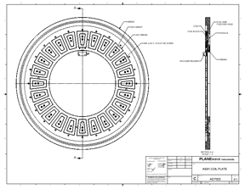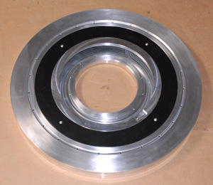

The CDK 700 azimuth drive assembly is more than a motor. It is a 3 phase 24 volt AC direct drive torque motor, with an integrated high resolution encoder, and an integrated 22.5” bearing. This assembly is both the base of the telescope and the drive. On the left is a drawing of the assembly that illustrates how compact it is, while a piece of the assembly being machined is shown on the right.

The 28-inch primary is relatively easy to manufacture, as is the 11-inch spherical secondary. The two-element corrector employs all spherical surfaces. The well corrected field supports the largest commercially available CCD sensors available today, and should continue to do so well into the future. The large, flat field is very useful for a variety of off-axis guider configurations.

Sidereal Technology Direct Drive Controller The controller electronics and software for both the Cal Poly 18 and PlaneWave Instruments CDK 700 were designed by Dan Gray, and are manufactured by Sidereal Technology. For precision telescope motion, brushless direct drive motors must be operated in an AC synchronous, servo-control mode. The position of the telescope is sensed with ultra-high precision encoders on the two telescope axes, the position error is calculated, and the requisite torque feedback is computed. The three phases of the motor are then energized based on this feedback torque by way of pulse-width modulated switches. This control system is ASCOM compliant, so it can be used with a number of overall telescope/observatory high-level supervisory software suites.

The 2.5 Meter Corrected Dall Kirkham Project As an off-shoot to the Alt-Az Initiative, Caisey Harlingten and Craig Breckenridge are developing a higher-end 2.5 meter alt-az CDK telescope to be used at the university level. Borrowing many ideas presented elsewhere in this paper, the goal is to produce a singular design that can be produced in volume in order to lower manufacturing costs.

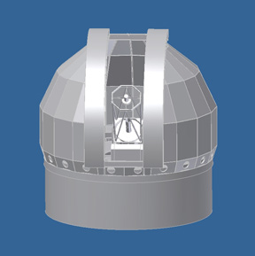
The 2.5 meter CDK telescope (left) and low cost enclosure (right). Remote operation is a key feature of the overall design.

The initial design includes the direct drive motors, dual position tertiary mirror, and Alt-Az concept with field rotators discussed elsewhere. The design is based on an optical configuration by Dave Rowe. Caisey and Craig plan to make telescopes more affordable for universities by utilizing a flat field of view and focal length that provides a good compromise between telescopes used for discovery and follow-up research. The design follows their philosophy of efficient thermal and mechanical design coupled with an equally efficient enclosure design. Both telescope and enclosure are designed to be operable remotely. The initial prototype for this telescope will start production in the fall of 2009.

Undergraduate Student Research and Telescope Development

The Initiative is actively pursuing the vital connection between small telescopes and the training of a new generation of astronomers and instrumentalists. A number of institutions with limited budgets are developing research programs that utilize low cost telescope technology. To date, several dozen undergraduate students at Cuesta College have participated in astronomical research programs resulting in published papers. They utilize both local observatories and remote, robotic observatories to observe a wide range of celestial phenomena including visual double stars, eclipsing binaries, intrinsic variable stars, asteroid rotation rates, and exoplanet transits.

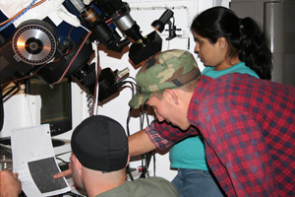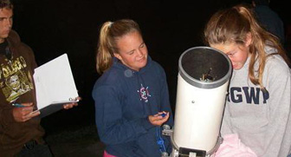
Cuesta College research seminar students observe an intrinsic variable star (left) and Arroyo Grande High School students (taking a Cuesta College research seminar) make astrometric measurements of visual double stars (right). Their results have been published in Society for Astronomical Science Symposium Proceedings, The Alt-Az Initiative (book in press), and the Journal of Double Star Observations.

Similarly, a dozen California Polytechnic State University, San Luis Obispo (Cal Poly) engineering (ME and EE) students have been or are currently involved in the design and fabrication of a research grade alt-az telescope, instrument rotator, and low cost, active primary mirror support electronics.

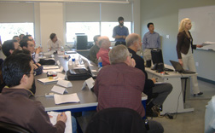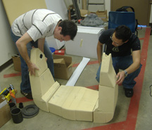
The Cal Poly engineering students present their design for an 18-inch Newtonian focus alt-az telescope at a critical design review (left). Two Cal Poly ME students fabricate the fork of the telescope. They designed the fork using finite element analysis (right). The foam core was later covered with multiple layers of carbon fiber cloth.

These research and engineering students have given presentations at multiple Initiative workshops and conferences, and have coauthored Initiative papers. One Cuesta College student, Jo Johnson, co-chaired two Initiative conferences and is co-editing the Initiative’s forthcoming book.

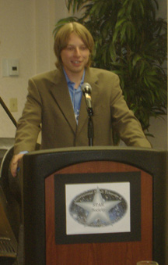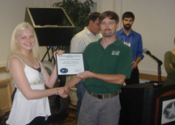
Cuesta College student Jolyon Johnson co-chaired two conferences for the Alt-Az Initiative: the STAR Conference in California (left) and Galileo’s Legacy in Hawaii. Cal Poly engineering student Michelle Kirkup receives a certificate of recognition from Professor John Ridgely at the STAR Conference for her participation in designing the Cal Poly 18-inch alt-az telescope (right).

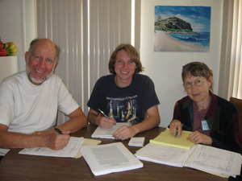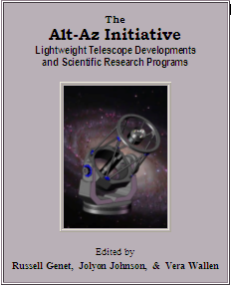
Russell Genet, Jolyon Johnson, and Vera Wallen (left to right) are editing the Initiative’s book The Alt-Az Initiative: Lightweight Telescope Developments and Scientific Research Programs. This book discusses all aspects of the Initiative in detail (left). The cover of the Initiative book features the Initiative’s first production spin-off, PlaneWave Instruments CDK 700 telescope silhouetted against the galaxy M81 (right).

Acknowledgements

The Initiative members are pleased to acknowledge the kind support of a number of institutions, including California Polytechnic State University, Cuesta College, the Gemini Observatory, and the American Association of Variable Star Observers, as well as a number of companies including Sidereal Technology, PlaneWave Instruments, Sierra Monolithics, Hubble Optics, and Inca Corp. We also thank Cheryl Genet for assembling and preparing the graphics for this report.

References

Baily, Pierre, ed., 2003. The Design and Construction of Large Optical Telescopes. New York: Springer.
Banich, Howard, 2006. “A Portable 28-inch Alt-Az Telescope.” Amateur Astronomy, Summer 2006, Vol. 50, pgs. 46-52.
Bartels, Mel, 1994. “How to Build a Simple Computerized Altazimuth Control System”, Observatory Techniques, Vol. 12, pgs. 12-15, Winter 1994.
------, 1999. “A Computerized Dobsonian,” Amateur Telescope Making, ed. Stephen Tonkin, Springer, pgs. 155-178.
------, 2000, “Keep up with the Stars, A Motorized Telescope Control”, Circuit Cellar, Vol. 119 June 2000, pgs. 18-25.
Basaila, George, 1988. The Evolution of Technology. New York: Cambridge University Press.
Genet, R., Rowe, D., Gray, D., Albertson, B., Chiu, W., Kirkup, M., Murphy, D., Ridgely, J., Schmitt, J., Swanson, M., Urban, R., Liu, T., Banich, H., Chelborad, C., and Keller, A., 2007. “An 18-Inch Direct-Drive Telescope,” in Proceedings of the Society for Astronomical Science, Brian Warner, ed., Vol. for 2007.
Genet, Russell, Johnson, Jolyon, and Wallen,Vera, in publication. The Alt-Az Initiative: Lightweight Telescope Developments and Scientific Research Programs. Santa Margarita CA: Collins Foundation Press.
Kriger, David and Berry, Richard, 2003. The Dobsonian Telescope: A Practical Manual for Building Large Aperture Telescopes. Richmond VA: Willmann-Bell.
Mertz, Lawrence, 1996. Excursions in Astronomical Optics. New York: Springer.
ReSTAR Committee, 2007. “Renewing Small Telescopes for Astronomical Research.” Report available at www.ReSTAR.com.
Ringwald, F. A., Culver, J. M., Lovell, R. L., Kays, S. A., & Torres, Y. V. A., 2003. “The Research Productivity of Small Telescopes and Space Telescopes.” Bulletin of the American Astronomical Society, 35, No. 4, 1063-1074.
Trueblood, Mark and Genet, Russell, 1985. Microcomputer Control of Telescopes. Richmond VA: Willmann-Bell.
Weaver, Bruce, 2003. “Funding of the Essential Synergy between Small and Large Telescopes,” in Terry Oswalt, ed., The Future of Small Telescopes in the New Millennium, Vol.1. Astrophysics and Space Science Library, Vol. 287. Dordrecht, Germany: Kluwer Academic Publishers.

