An 18-Inch Direct Drive Alt-Az Telescope

Russell M. Genet
Research Scholar in Residence Program
California Polytechnic State University, San Luis Obispo, CA
russmgenet@aol.com

Dave Rowe
Starry Ridge Observatory, Cloudcroft, NM
dave@starryridge.com

Dan Gray
Sidereal Technology, Portland OR
grayarea@siderealtechnology.com

Billy Albertson, Wilson Chiu, Michelle Kirkup, Drew Murphy, John Ridgely,
Josh Schmitt, Matt Swanson, and, Rob Urban
Department of Mechanical Engineering
California Polytechnic State University, San Luis Obispo, CA
jridgely@me.calpoly.edu

Tong Liu
Hubble Optics, Hong Kong, China
info@hubble-optics.com

Howard Banich
Nike, Portland, OR
howard.banich@nike.com

Cary Chelborad and Allan Keller
Optical Structures
cary@opticalstructures.com, allan@opticalstructures.com
Abstract
A modest aperture alt-az telescope has been designed and is being built for student use at California Polytechnic State University. The telescope’s drive system has no gears, belts, or friction wheels; instead direct drive motors and high resolution encoders are completely integrated into the bearing assemblies and telescope superstructure. In altitude, for instance, a ring of permanent magnets is firmly mounted to the OTA while an opposing ring of coils is mounted on the inside of a fork arm. The electronic control system has been designed to operate these brushless motors in a high precision mode. To achieve the highest possible closed loop servo bandwidth, the structure was designed—using finite element analysis as well as traditional tools—to have a very high natural frequency. The direct drive system and stiff structure should effectively counter wind gusts when the telescope is operated out in the open or within a roll-off roof observatory. © 2007 Society for Astronomical Sciences.

- Introduction
At last year’s Society of Astronomical Science (SAS) conference, several of us discussed possible advanced technologies and designs for research quality alt-az telescopes in the 0.4 to 2.0 meter range. Since the 2007 SAS conference we have formed an informal exploratory group that has met eight times. Several articles on this group’s deliberation have already been published including a description of the group’s overall efforts (Genet et al 2007), a preliminary design of a direct drive, 0.7-meter corrected Dall Kirkham (CDK) telescope with a Nasmyth focus (Rowe et al 2007), and a summary of two workshops (Genet 2007, and Corneau 2007).
The alt-az group decided, in early January 2008, to develop and evaluate some of their ideas by designing and building an 18-inch Newtonian telescope. In this paper we provide a summary description of the design features of this telescope, beginning with the direct drive motors and control electronics.

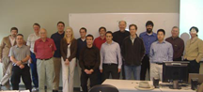

Figure 1. Alt-az group members at the 18-inch Critical Design Review at Cal Poly in mid March.

- Direct Drive Motors
The objective of direct drive motors is to dispense entirely with gears, belts, shafts, friction drives, or any other mechanical transmission, and replace them with large-diameter, high-torque stators and rotors directly mounted to the telescope itself. The telescope’s bearings become the motor’s bearings, while the telescope’s structure becomes the motor’s “frame,” hence the term “frameless motor.” Positional feedback is provided from high resolution encoders mounted directly on each telescope’s axis, and a servo controller closes the loop around the encoders.
The primary advantage of direct drive is the elimination of the mechanical transmission and the compliance, backlash, periodic error, and other undesirable characteristics associated with them. Properly implemented, direct drive motors in conjunction with directly-coupled high resolution encoders and a stiff structure can, at least in theory, provide the stiffest, most responsive telescope control possible.
As suggested by Beley (2003) in his classic book, The Design and Construction of Large Optical Telescopes, “Direct drive motors are structurally simple and have no moving parts. They are intrinsically free from friction and stick-slip effects and need no maintenance.”
Beley then points out that the disadvantage of direct drives is their relatively high cost. This is why they are not usually incorporated in smaller telescopes. Rowe, however, has circumvented this difficulty by designing, for our alt-az group, a direct drive motor that uses readily available parts and materials (costing about $200) that is amazingly easy to construct.
Essentially all currently available direct drive motors are radial flux motors with permanent magnets mounted on an iron cylinder forming the rotor, and radial coils wound over iron cores situated around the periphery forming the stator. While such a radial flux, direct drive motor is energy efficient, it is difficult and expensive to construct using the common techniques in current practice.
Rowe realized that power efficiency was not a critically important requirement for smaller telescopes because they generally move slowly—only infrequently slewing at higher speeds, and that an axial flux motor as opposed to radial flux motor would be much easier to build and integrate into the telescope, albeit with lower overall efficiency.
The motor is quite simple to build. For the rotor, 4N rare earth permanent magnets are evenly spaced and epoxied on to a soft iron annulus, arranged with alternating poles. (These magnets are very powerful, and one must not let two of them get too close together as they can easily crush a finger.) The stator consists of 3N coils epoxied to a non-ferrous aluminum or plastic annulus of the same size. The coils are wired in three phases. On the first test motor, the annuli had a 20 inch OD and an 18 inch ID. The rotor ring was made of soft steel while the stator ring was made of epoxy and plywood. The prototype motor achieved a torque constant of more than 10 N-m/amp during bench testing.

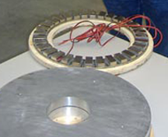

Figure 2. In the foreground is the azimuth assembly, and in the background a test coil assembly.

For the 18-inch telescope, the azimuth direct drive motor, encoder, and bearings have been integrated into a single, quite thin unit designed by Rowe. Two 18-inch diameter cast aluminum disks have been machined to provide V-grove bearing tracks on their periphery, support for the magnets and coils of the direct drive motors (inward from the bearing groves), and space toward the center for an 8-inch diameter Renishaw tape encoder disk and read head.

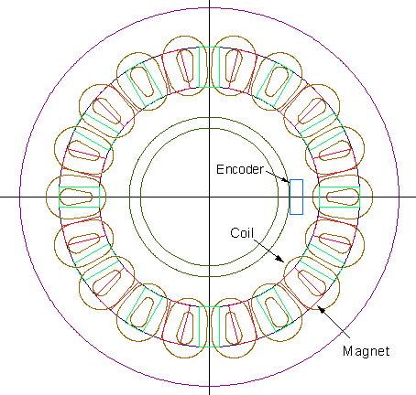
Figure 3. A simplified plan view of the direct drive motor, encoder and bearing assembly used for the azimuth axis.

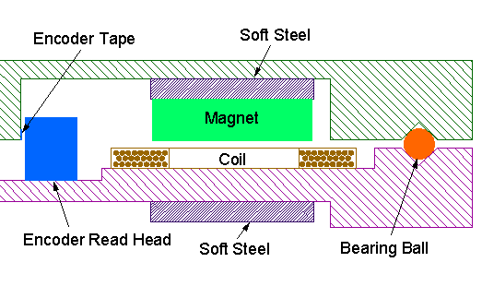Figure 4. A simplified cross section of the direct drive motor, encoder and bearing assembly for the azimuth axis.

- Control Electronics
Direct drive motors can be operated in two quite different modes. By far the most common mode is a permanent magnet, brushless DC motor. Such brushless motors are widely used in air conditioners, refrigerators, and electric bicycles, not to mention new, top end washing machines and driers. In these motors, commutating brushes have been replaced with Hall effect sensors and electronic switches (typically MOSFETs). These motors have no brushes to wear out.
Less frequently, when exact positioning or very high precision speed control is required, direct drive motors are operated inside a servo control loop. In this mode, the angular position of the motor is sensed by a high resolution encoder. This position information is used to provide, via trigonometric functions and precision analog-to-digital (A/D) converters, precise currents for the motor’s multiphase windings. In this mode, the motor is effectively generating torque, commanded by the closed loop servo algorithm. This closed-loop control system keeps the motor essentially “locked” to the exact desired position whether the motor is rotating or standing still.
The control electronics for direct drive motors operated in the brushless DC motor mode are quite simple, and only cost a few dollars. The control electronics for direct drive, brushless DC motors operated in closed-loop feedback mode are more complex, requiring high resolution encoders, a computer to run the feedback algorithms, high resolution analog-to-digital (A/D) converters, and high current switches.
Gray, at Sidereal Technology, has developed the electronics and firmware that will control two direct drive servo systems using three-phase brushless DC motors and high resolution encoders. In addition, this new control system will operate brushed DC servo motors and stepper motors. With the ability to read encoders at a 6 MHz rate, this new “Turbo Drive” controller accommodates both high resolution encoders and fast slew rates. A 5x7 inch, five layered board contains the complete telescope control system.

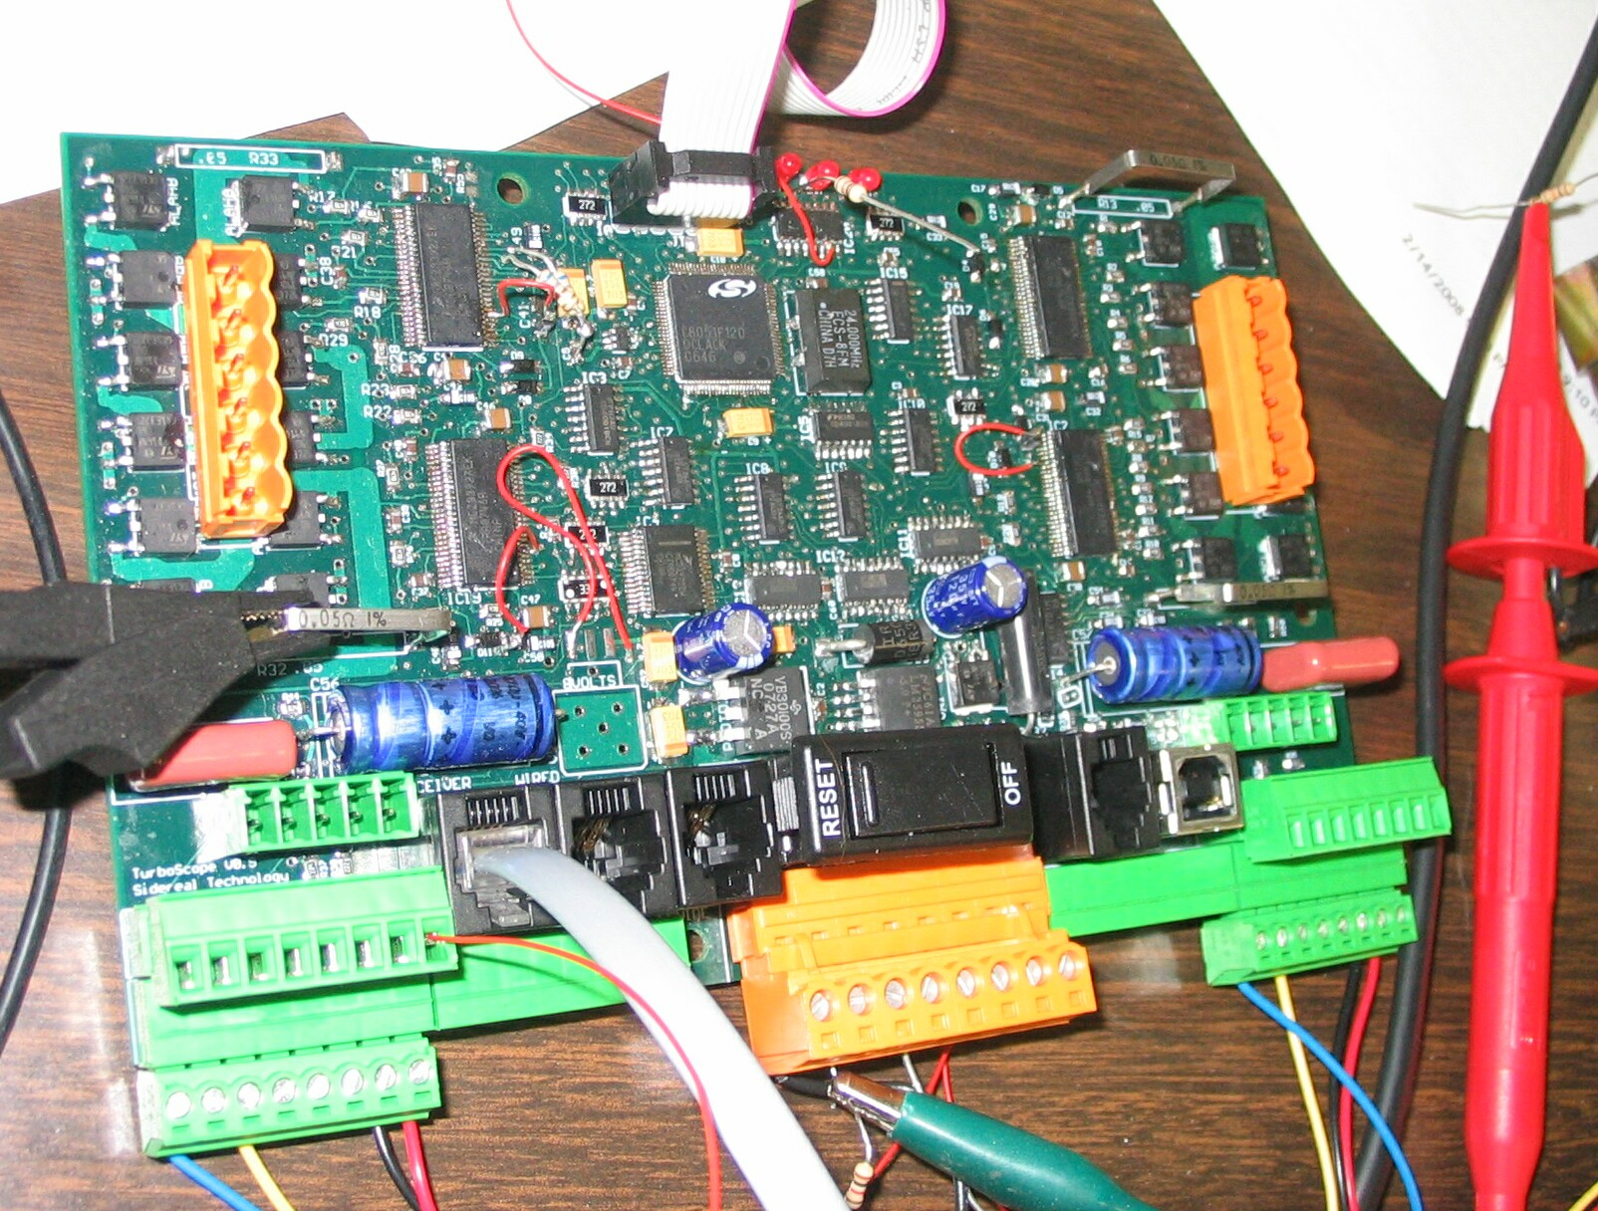
Figure 5. Sidereal Technology Turbo Drive control system.

- OTA and Fork Structures
The telescope’s primary structural components—the optical tube assembly (OTA) and fork—have been designed and are being built by two student teams at California Polytechnic State University San Luis Obispo. The OTA team consists of Chiu, Kirkup, Schmitt, and Swanson, while the fork team consists of Albertson, Murphy, and Urban. The OTA and fork team efforts are senior projects in Professor James Widmann’s mechanical engineering class. The teams are being advised by Professors Ridgely and Genet.
Both simplified mathematical analysis and computerized finite element analysis (FEA) were used to design these stiff structures. It was specified that the lowest resonant frequency of the mechanical system not be below 10 Hz, allowing the control system to effectively counter wind disturbances up to roughly this frequency without the control system’s performance being degraded by interactions with structural resonances.
These goals were achieved in the design. In simulation by FEA, the lowest resonant frequency of the OTA (loaded with its optics and instruments) is approximately 40 Hz, while the lowest resonant frequency of the fork (loaded with the OTA with its optics and instruments) is greater than 10 Hz. Carbon fiber composites (CFCs) were utilized in the OTA’s truss tubes and top end, and also in most of the fork to facilitate a stiff, lightweight structure.

Figure 6. Isometric View of the OTA

The OTA’s square top end allows the spiders for the secondary assembly to be placed under considerable tension, helping to maintain stiffness in the entire top end. The square top also provides a flat surface for mounting the instrument rotator / focuser at the Newtonian focus.
The OTA’s square lower section is made from aluminum alloy. The combination of aluminum and carbon fiber along the optical axis compensates, fairly closely, for temperature induced changes in the focal length of the primary mirror.

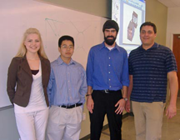

Figure 7. OTA team, left to right: Michelle Kirkup, Wilson Chiu, Matt Swanson, and Josh Schmitt.

The fork was designed to directly transition the load from the two altitude bearings to the large diameter (18 inch) azimuth bearing. The fork features a polyurethane foam core, CFC exterior, reinforcing internal steel plates, and a steel azimuth bearing interface cylinder. A compartment in the bottom of the fork provides generous space for the telescope’s control electronics, instrument power supplies, etc.
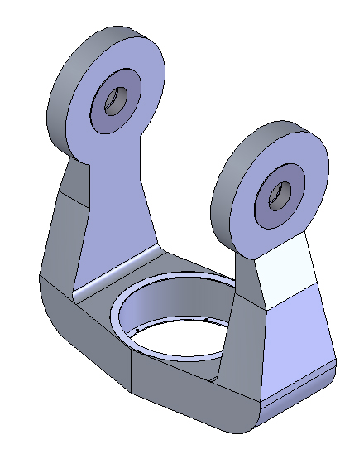
Figure 8: The carbon fiber fork with steel center ring.

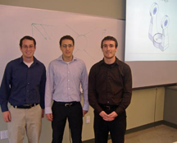

Figure 9. Fork team, left to right: Drew Murphy, Billy Albertson, and Rob Urban

- Optics and Optical Support
The optical layout, including the baffles, was designed by Rowe. The primary mirror, designed and fabricated by Liu at Hubble Optics, is an f/4 parabola 18 inches in diameter. Two relatively thin disks of plate glass are separated by round glass spacer disks, and the entire structure has been fused together.

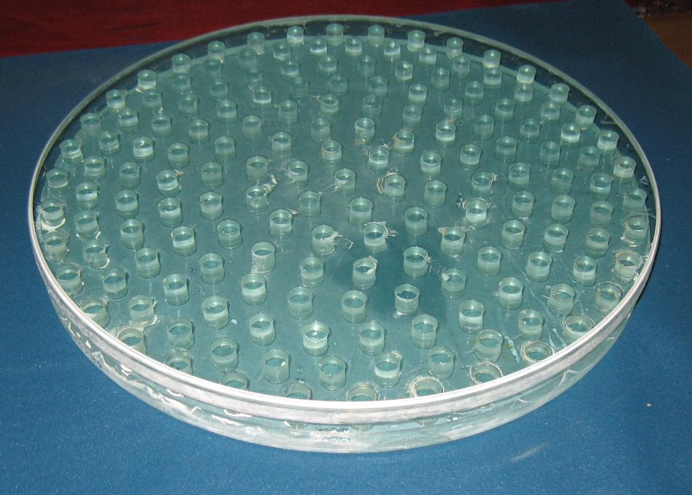

Figure 10. 18-inch f/4 Sandwich Mirror

This sandwich structure has two advantages: (1) the two spaced out thin plates cool quickly as compared to an equivalent solid mirror, and (2) the sandwich mirror weighs less than a solid mirror of similar stiffness. Although this 18 inch, f/4 mirror has a flat back and two layers of glass separated by spacers, Hubble Optics makes much larger diameter mirrors with curved (slumped) plates and additional layers of plate disks and spacers.
While the coefficient of thermal expansion (CTE) of plate glass is higher than that of borosilicate, the changing primary focal length has been almost exactly compensated for by an appropriate combination of carbon fiber trusses and aluminum lower-end structure.

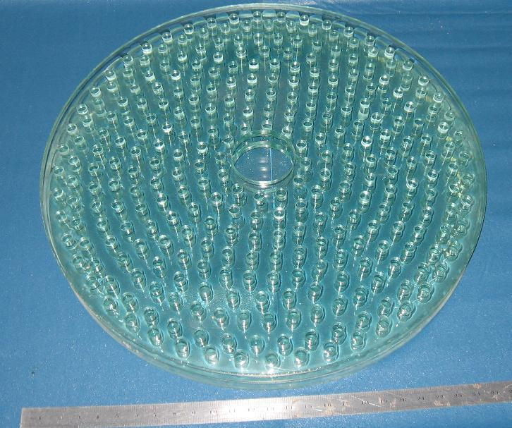

Figure 11. 3-Layer 25-inch Sandwich Mirror

The 18-point primary mirror support was designed by and is being fabricated by Banich. The parts are being cut out by a numerically controlled water jet machine.

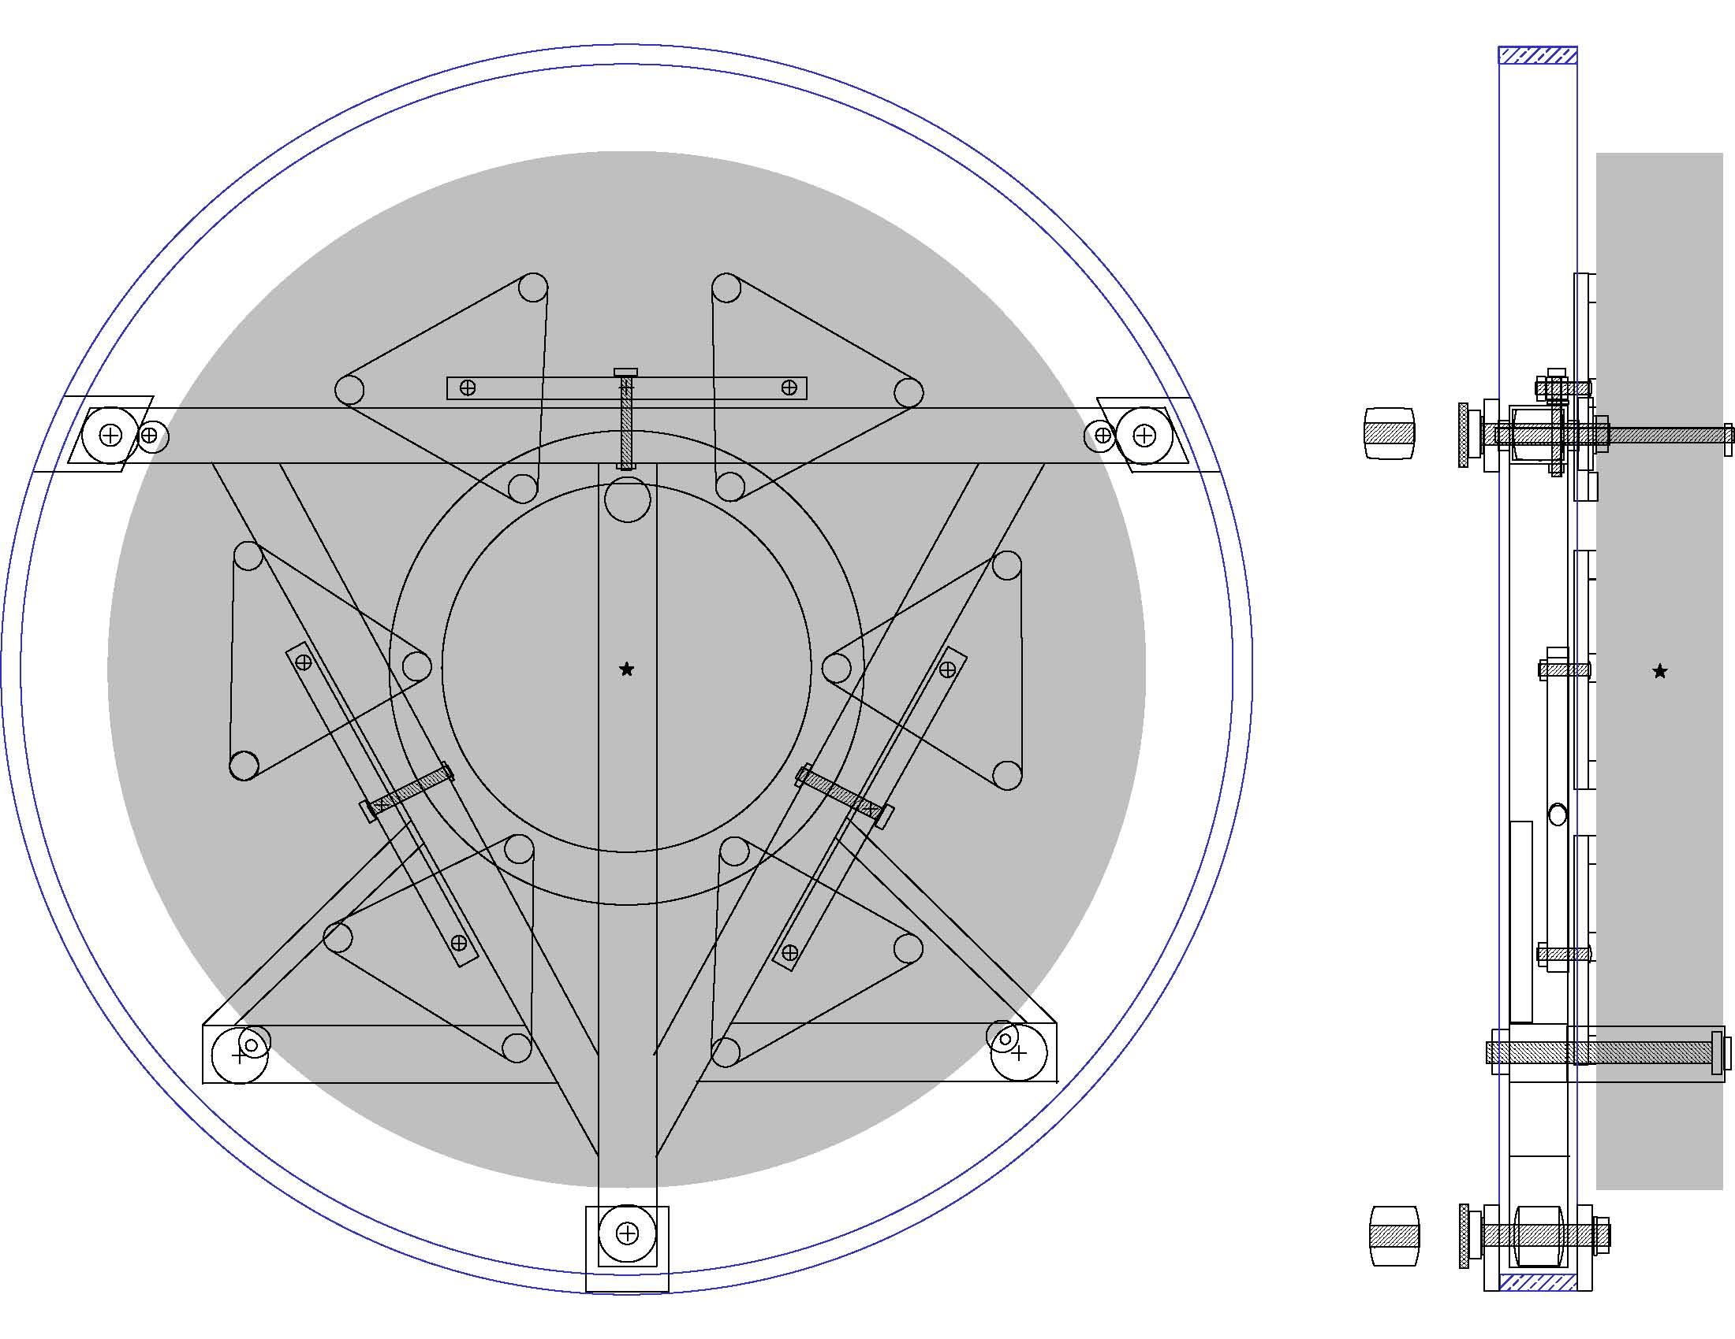

Figure 12: The 18 inch primary mirror cell, back and side views.

The center of gravity (CG) of the secondary optical

The secondary mirror, being designed and fabricated by Chelborad and Keller at Optical Structures, is a very lightweight, cast borosilicate design. The 5.5 inch minor axis provides the generous backfocus needed by the instrumental payload, which can include an instrument rotator, deviator plate, off-axis guider, filters, and CCD camera.

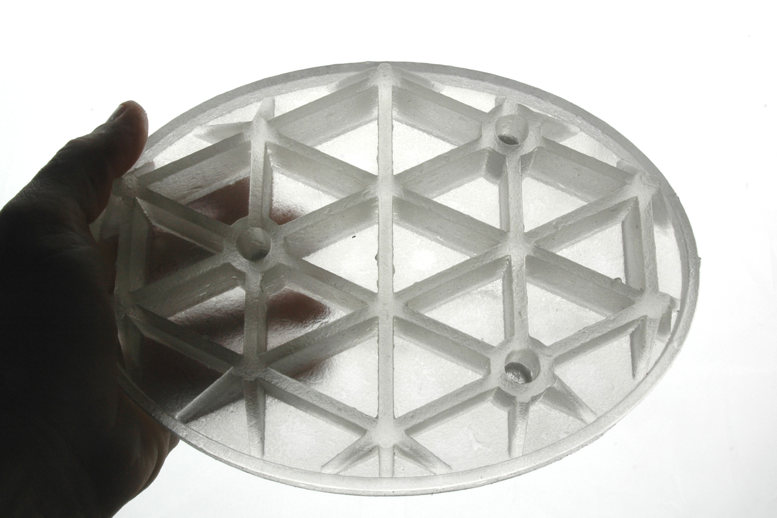

Figure 13. The light-weight cast borosilicate secondary mirror made by Optical Structures.

The secondary optical assembly which surrounds and supports the secondary mirror was designed by and is being fabricated by Banich. The secondary mirror support structure and secondary baffle have been integrated into a single structure designed to transmit forces from opposing, tightly tensioned spiders.

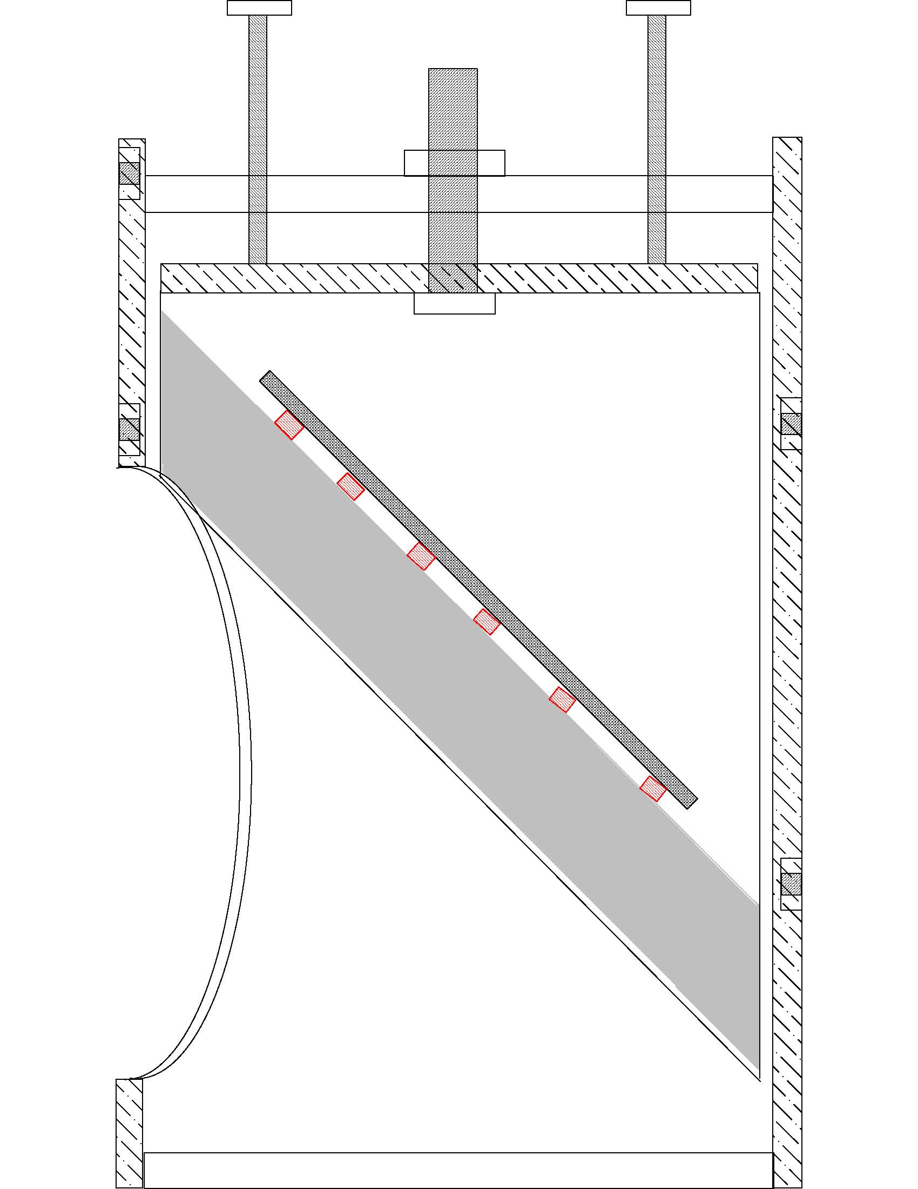

Figure 14. Side view of the 6 inch diagonal holder inside its baffle and spider hub.

The center of gravity (CG) of the secondary optical assembly has been located to minimize torsional loads on the spider vanes. The spider vanes are tensioned to the corners of the square OTA top end (the four corners at the top of the top end “cage” and four at the bottom).

- Conclusion and Future Efforts
Although much of the construction and all of the evaluation remains to be accomplished, we are confident at this point in time that the combination of direct drive motors operated inside a servo loop closed around high resolution encoders, lightweight mirrors, and an FEA designed CFC/aluminum structure can provide an unusually light and stiff telescope that should perform well under gusty wind conditions out in the open or in a roll-off-roof observatory.
Although our informal alt-az developmental group is currently concentrating on completing the construction and evaluation of the 18-inch telescope described above, we are giving thought to several future initiatives. We welcome others to join us in these ventures.
We expect that our next alt-az development project will either be a 0.7 or 0.75 meter corrected Dall Kirkham telescope with a Nasmyth focus. This telescope will feature an unusually large diameter, well corrected field of view that will accommodate very large format cameras. It will also feature a built in instrument rotator and autoguider, and a built-in deviator plate for very high speed corrections.
Beyond this, we are exploring a number of possibilities for designing and constructing unusually lightweight, low cost, larger aperture (1 to 2 meter) telescopes. These telescopes would be specialized photometric or spectroscopic telescopes as opposed to more general purpose, high quality imaging telescopes. Under consideration are multiple lightweight mirrors in a spherical configuration, low cost active control of a single thin meniscus mirror (Wilson 2001), and ultra-lightweight carbon fiber composite (CFC) mirrors. The transfer of some of these technologies from larger to smaller telescopes is being explored (Genet et al 2008).

- Acknowledgements
We wish to thank the Society for Astronomical Science for their annual conference which provided a forum for bringing many of us together for the first time last year (May 2007), and reuniting many of us again this year. We thank the Research Scholars in Residence Program at California Polytechnic State University for hosting the Small Telescope and Astronomical Research (STAR) workshop (Genet et al 2007) that further explored these ideas. We also thank the Texas Astronomical Society, Dallas, for hosting the Alt-Az Telescope Workshop (Corneau 2008), and the Gemini Observatory for hosting two workshops in Hilo. We are pleased to thank Sidereal Technology for hosting two workshops in Portland, Oregon, Impact Bearings for hosting a workshop in Ocean View (Hawaii), and Trust Automation for hosting a workshop in San Luis Obispo, California. We thank the Mechanical Engineering Department at California Polytechnic State University for hosting the Critical Design Review for the 18-inch telescope in mid March 2008, and Rowe for hosting the most recent meeting, held at the Roweville Star Party in the Mojave National Preserve in early April 2008.
All the authors of this paper have generously contributed their time and funds to this project. We are pleased to acknowledge component contributions by the following firms: Hubble Optics (primary mirror), Optical Structures (secondary mirror), PlaneWave Instruments (truss tubes and clamps), and Sidereal Technology (control electronics).
Finally, we are pleased to acknowledge the financial donations by the following firms for the materials and components needed to fabricate the OTA and fork structures by the two California Polytechnic State University student teams. These donors included Dan Gray (Technical Marine Services), Charles Harper (Sierra Monolithics), Richard Hedrick (PlaneWave Instruments), Richard Kay (Impact Bearings), Ken Kissell (Kissell Associates), and George Roberts (Inca Inc.)

- References
Beley, Pierre Y., ed. (2003). The Design and Construction of Large Optical Telescope. New York: Springer.

Corneau, M. (2008). “The Dallas Alt-Az Telescope Workshop. Astronomy Technology Today. vol. 1, issue 7, pp 53-59.

Genet, R. (2007). “STAR Workshop 2007: Small Telescope Astronomical Research.” Astronomy Technology Today, vol. 1, issue 4, pp 27-36.

Genet, R., D. Gray, H. Banich, D. Rowe, T. Smith, and T. Krajci (2007). “Alt-Az Telescopes for Research, Astrophotography, and Education.” Amateur Astronomy, number 56, pp 59-69.

Genet, R., D. Gray, C. Carter, M. Sheehan, D. Tomano, H. Takami, C. Genet, J. Archambeau. (in press). “Visit to Gemini and Subaru 8-Meter Telescopes on Mauna Kea.” Amateur Astronomy.

Rowe, D., R. Genet, D. Gray, R. Hedrick, R. Peasely, T. Liu, T. Safreno, J. Ridgely, H. Banich, T. Krajci, T. Smith, J Widman, X. Yu, J. Habermann, R. Berry, M. Bartels, R. Kay, C. Breckenridge, and J. Johnson (2007). “Portable 0.7-Meter CDK Alt-AZ Telescope for Research, Astrophotography, and Visual Observation.” Amateur Astronomy, number 57.

Wilson, R. N. (2001). Reflecting Telescope Optics II: Manufacturing, Testing, Alignment, Modern Techniques. Berlin: Springer-Verlag.

